School Calendar 2023-2024 – Virgin Mary Boys’ National School, 19302u
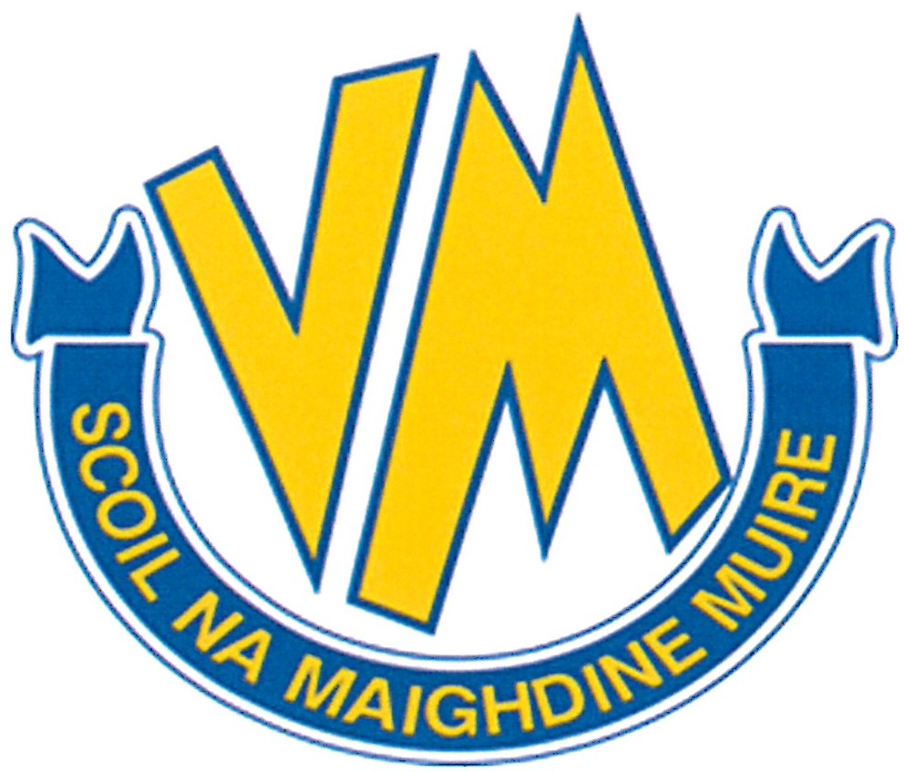
August 2023 |  |  |  |  |  |  |  |  | September 2023 |  |  |  |  |  |  |  |  | October 2023
Wk | Mo | Tu | We | Th | Fr | Sa | Su |  | Wk | Mo | Tu | We | Th | Fr | Sa | Su |  | Wk | Mo | Tu | We | Th | Fr | Sa | Su
31 |  | 1 | 2 | 3 | 4 | 5 | 6 |  | 35 |  |  |  |  | 1 | 2 | 3 |  | 39 |  |  |  |  |  |  | 1
32 | 7 | 8 | 9 | 10 | 11 | 12 | 13 |  | 36 | 4 | 5 | 6 | 7 | 8 | 9 | 10 |  | 40 | 2 | 3 | 4 | 5 | 6 | 7 | 8
33 | 14 | 15 | 16 | 17 | 18 | 19 | 20 |  | 37 | 11 | 12 | 13 | 14 | 15 | 16 | 17 |  | 41 | 9 | 10 | 11 | 12 | 13 | 14 | 15
34 | 21 | 22 | 23 | 24 | 25 | 26 | 27 |  | 38 | 18 | 19 | 20 | 21 | 22 | 23 | 24 |  | 42 | 16 | 17 | 18 | 19 | 20 | 21 | 22
35 | 28 | 29 | 30 | 31 |  |  |  |  | 39 | 25 | 26 | 27 | 28 | 29 | 30 |  |  | 43 | 23 | 24 | 25 | 26 | 27 | 28 | 29
 |  |  |  |  |  |  |  |  |  |  |  |  |  |  |  |  |  | 44 | 30 | 31
November 2023 |  |  |  |  |  |  |  |  | December 2023 |  |  |  |  |  |  |  |  | January 2024 |  |  |  |  |  |  |  |  | February 2024
Wk | Mo | Tu | We | Th | Fr | Sa | Su |  | Wk | Mo | Tu | We | Th | Fr | Sa | Su |  | Wk | Mo | Tu | We | Th | Fr | Sa | Su |  | Wk | Mo | Tu |  | We | Th | Fr | Sa | Su
44 |  |  | 1 | 2 | 3 | 4 | 5 |  | 48 |  |  |  |  | 1 | 2 | 3 |  | 1 | 1 | 2 | 3 | 4 | 5 | 6 | 7 |  | 5 |  |  |  |  | 1 | 2 | 3 | 4
45 | 6 | 7 | 8 | 9 | 10 | 11 | 12 |  | 49 | 4 | 5 | 6 | 7 | 8 | 9 | 10 |  | 2 | 8 | 9 | 10 | 11 | 12 | 13 | 14 |  | 6 | 5 | 6 |  | 7 | 8 | 9 | 10 | 11
46 | 13 | 14 | 15 | 16 | 17 | 18 | 19 |  | 50 | 11 | 12 | 13 | 14 | 15 | 16 | 17 |  | 3 | 15 | 16 | 17 | 18 | 19 | 20 | 21 |  | 7 | 12 | 13 |  | 14 | 15 | 16 | 17 | 18
47 | 20 | 21 | 22 | 23 | 24 | 25 | 26 |  | 51 | 18 | 19 | 20 | 21 | 22 | 23 | 24 |  | 4 | 22 | 23 | 24 | 25 | 26 | 27 | 28 |  | 8 | 19 | 20 |  | 21 | 22 | 23 | 24 | 25
48 | 27 | 28 | 29 | 30 |  |  |  |  | 52 | 25 | 26 | 27 | 28 | 29 | 30 | 31 |  | 5 | 29 | 30 | 31 |  |  |  |  |  | 9 | 26 | 27 |  | 28 | 29
March 2024 |  |  |  |  |  |  |  |  | April 2024 |  |  |  |  |  |  |  |  | May 2024 |  |  |  |  |  |  |  |  | June 2024
Wk | Mo | Tu | We | Th | Fr | Sa | Su |  | Wk | Mo | Tu | We | Th | Fr | Sa | Su |  | Wk | Mo | Tu | We | Th | Fr | Sa | Su |  | Wk | Mo | Tu |  | We | Th | Fr | Sa | Su
9 |  |  |  |  | 1 | 2 | 3 |  | 14 | 1 | 2 | 3 | 4 | 5 | 6 | 7 |  | 18 |  |  | 1 | 2 | 3 | 4 | 5 |  | 22 |  |  |  |  |  |  | 1 | 2
10 | 4 | 5 | 6 | 7 | 8 | 9 | 10 |  | 15 | 8 | 9 | 10 | 11 | 12 | 13 | 14 |  | 19 | 6 | 7 | 8 | 9 | 10 | 11 | 12 |  | 23 | 3 | 4 |  | 5 | 6 | 7 | 8 | 9
11 | 11 | 12 | 13 | 14 | 15 | 16 | 17 |  | 16 | 15 | 16 | 17 | 18 | 19 | 20 | 21 |  | 20 | 13 | 14 | 15 | 16 | 17 | 18 | 19 |  | 24 | 10 | 11 |  | 12 | 13 | 14 | 15 | 16
12 | 18 | 19 | 20 | 21 | 22 | 23 | 24 |  | 17 | 22 | 23 | 24 | 25 | 26 | 27 | 28 |  | 21 | 20 | 21 | 22 | 23 | 24 | 25 | 26 |  | 25 | 17 | 18 |  | 19 | 20 | 21 | 22 | 23
13 | 25 | 26 | 27 | 28 | 29 | 30 | 31 |  | 18 | 29 | 30 |  |  |  |  |  |  | 22 | 27 | 28 | 29 | 30 | 31 |  |  |  | 26 | 24 | 25 |  | 26 | 27 | 28 | 29 | 30

Holidays 2023/24 Please do not plan holidays when the school is open. We are obliged to inform the Education Welfare Officer when a child has missed 20 school days.
August 28 | School Reopens |  | February 5 | Bank Holiday |  | May 6 | Bank Holidays
October 30 & 31 | Bank Holiday & Midterm |  | February 12 – 16 | Midterm break |  | June 3 – 7 | Midterm break
November 1, 2 & 3 | Midterm break |  | March 18 | Bank Holiday |  | June 28 | School finishes at 12 noon
December 22 | School finishes at 12noon |  | March 22 | School finishes at 12 noon
Dec. 25 – Jan. 5 | Christmas Holidays |  | March 25 – April 5 | Easter Holidays |  |  | Calendar subject to change.
Principal: Aisling Cox, Home School Community Liaison (HSCL) : Siobhan Mac Hale, Email : info@virginmarybns.ie, Phone : 018421314

